**Experiment No.3**

**Aim**: To implement two‐sample Z‐test.

**Prerequisites**: python.

**Objectives:** - At the end of this experiment, you will be able to:

* solving real life problems based on Statistical analysis
* Use Z test on the given problem

**Theory:** The two-sample z test is to tests the difference between means of two groups, whereas a [one-sample z test](https://sixsigmastudyguide.com/one-sample-z-hypothesis-test/) is to tests the difference between a single group and the hypothesized population value.

## Assumptions of Two sample Z hypothesis tests

* Population data is continuous
* Population follows a standard normal distribution
* Both sample ends must be higher than 30
* The population [standard deviation](https://sixsigmastudyguide.com/standard-deviation/) is known
* Similar spread between the groups, in other words homogeneity of variance
* Both the samples should be randomly selected from the population

## Two sample Z-test Formula

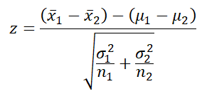

* x̅1 = sample mean of first sample
* x̅2 = sample mean of second sample
* µ1= Mean of first population
* µ2= Mean of second population
* σ12= population variance in first population
* σ22= population variance in second population
* n1= sample size of first group
* n2= sample size of second group

## Hypothesis Testing

A [tailed hypothesis](https://sixsigmastudyguide.com/tailed-hypothesis-tests/) is an assumption about a population parameter. The assumption may or may not be true. A one-tailed hypothesis is a test of hypothesis where the area of rejection is only in one direction. Whereas two-tailed, the area of rejection is in two directions. The selection of one or two-tailed tests depends upon the problem.

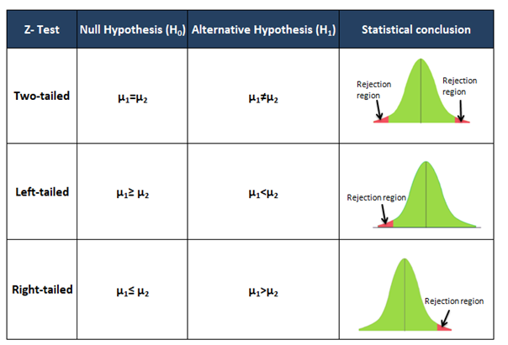

## Steps to Calculate Two Sample Z hypothesis test

* Select appropriate statistic- one-tailed or two-tailed?
* Determine the null hypothesis and alternative hypothesis
* Determine the level of significance
* Find the critical value
* Calculate the standardized test statistics
* Then make a decision to reject or fail to reject the null hypothesis. Reject the null hypothesis, If the test statistic falls in the critical region.
* Finally, interpret the decision in the context of the original claim.

Conclusion: - In this experiment, we have validated dataset by performing two-sample Z-test